Email, Fax or Mail, sealed RFP to - Fax 972-883-6879 RFP FROM  http://www.utdallas.edu/utdgeneral/business/procure/
The University of Texas at Dallas UTD
UTD Buyer: Jay Carter
Phone# 972-883-2302
Email: carterj@utdallas.edu

Or hand deliver/ air express Delivery Address:
The University of Texas at Dallas The University of Texas at Dallas
Purchasing M/S AD34 Central Receiving 972-883-2779
800 W CAMPBELL RD 800 W. CAMPBELL RD
RICHARDSON, TX 75080-3021 RICHARDSON, TX 75080-3021

For clarification of the Specifications, Responder may contact the UTD Department:

David R Holmes
dholmes@utdallas.edu
Director
Architecture & Infrastructure Services
972-883-2686
Office - MP3.204
Mailstop - MP18

List the RFP #, opening date, your company name on the submitted RFP envelopes or documents.

Enter your Federal Employer's Identification Number. Sole owner should also enter Social Security Number.

By signature hereon, Proposer offers and agrees to furnish the Services to University and comply with all terms, conditions, requirements and specifications set forth in this RFP:

Responder address:

Federal ID#: ______________________________________________________________________________

Vendor Name: _____________________________________________________________________________

Address: _________________________________________________________________________________

City-State-Zip: _____________________________________________________________________________

Phone/Fax/email: __________________________________________________________________________

Printed Name: _____________________________________________________________________________

Signature: ________________________________________________________________________________

Group pricing. UTD will consider any offers available under Group government purchasing coops, group pricing such as: TXMAS, GSA, BUYBOARD, TCPN, USCommunities, E&I, DIR, Collin County Forum.

_____ Check here if you would like to make this offer available to other UT schools.

_____ Check here to make this offer available to other government agencies.

_____ HUB. Check here if your company is certified by Texas http://www.window.state.tx.us/procurement/

SBA Small Business Administration Government-wide Procurement Preference Goaling Program
Check here if your company qualifies as one of the following per the SBA rules http://www.sba.gov/GC/goals/
_____ (SDB) Small Disadvantaged Business Concern
_____ (WOSM) Women-Owned Small Business Concern
_____ (HBCU) Historically Black Colleges and Universities and Minority Institutions (MI)
_____ (HUBZone SB) Hubzone Small Business Concerns
_____ (VOSB) Veteran-Owned Small Business Concerns
_____ Service-Disabled Veteran-Owned Small Business Concerns

Federal Funds: All procurements of supplies, equipment, and services utilizing Federal Funds (e.g., Federal Grant or Contract) shall be made in accordance with all applicable federal rules and regulations: Federal Acquisition Regulations (FAR), Federal Office of Management and Budget (OMB)

Educational Institutions (even if part of a State or local government) follow: OMB
- A-21 for cost principles
- A-110 for administrative requirements, and
- A-133 for audit requirements
http://www.whitehouse.gov/omb/circulars/index-education.html Circulars: Educational and Non-Profit Institutions Documents
http://www.whitehouse.gov/omb/circulars/a110/a110.html OMB Circular A110
http://www.epls.gov/ Excluded Parties List (Debarred Bidders List)
By signing this document vendor certifies they are in compliance with OMB A110 and are not on the Debarred Bidders List

Option to Extend. UTD shall have the option to extend this contract for 4 additional years (in 1 year increments) beyond this initial contract period. Notice shall be served at least 30 days prior to the end of the current contract period. If both the vendor and UTD agree to the new terms the contract may be renewed.

Right to Cancel. UTD shall have the right to cancel this contract with cause with 30 days notice during the initial year and without cause on a month to month basis during the renewal option years.

HUB. If this order is expected to go over $100,000 HUB Subcontracting Plan (HSP) Documents
are required by law to be supplied, available at this site: http://www.window.state.tx.us/procurement/prog/hub/hub-forms/
WE MAY HAVE TO DISQUALIFY ANY BID OVER $100,000 MISSING THE HSP DOCUMENTS!!!!

F.O.B. destination, freight prepaid and allowed. Or show exact delivery cost and terms.

Best Interest of UTD. The University reserves the right to accept or reject all or any part of any RFP, waive minor technicalities and award the RFP that best serves the interests of UTD.

Brand names, Catalogs, or manufacturer's references are descriptive only, and indicate type and quality desired. RFPs on brands of like nature and quality will be considered unless advertised as SOLE SOURCE If other than brand(s) specified is offered, illustrations and complete description of product offered are requested to be made part of the RFP.

Implied Use. All parts and work shall conform in strength, quality and workmanship to the accepted industry standards for the intended and implied use of a major University. Unless otherwise specified, items offered shall be new and unused and of current date codes. Proposer represents and warrants that all products and services offered to University in response to this RFP meet or exceed the safety standards established and promulgated under the Federal Occupational Safety and Health Law (Public Law 91-596) and the Texas Hazard Communication Act, Chapter 502, Health and Safety Code, and all related regulations in effect or proposed as of the date of this RFP.

Award of Contract - A response to an IFB is an offer to contract based upon the terms, conditions and specifications contained herein. RFPs do not become contracts until they are accepted through a purchase order. The contract shall be governed, construed and interpreted under the laws of the State of Texas.
Proposer acknowledges and agrees that (1) this RFP is a solicitation for a proposal and is not a contract or an offer to contract; (2) the submission of a proposal by Proposer in response to this RFP will not create a contract between University and Proposer; (3) University has made no representation or warranty, written or oral, that one or more contracts with University will be awarded under this RFP; and (4) Proposer will bear, as its sole risk and responsibility, any cost arising from Proposer’s preparation of a response to this RFP.

Gifts. The Contractor has not given, offered to give, nor intends to give at any time hereafter any economic opportunity, future employment, gift, loan, gratuity, special discount, trip, favor, or service to a public servant in connection with the submitted bid, offer, proposal or contract.

Indemnify. The Contractor shall defend, indemnify, and hold harmless UTD, all of its officers, agents and employees from and against all claims, actions, suits, demands, proceedings costs, damages, and liabilities, arising out of, connected with, or resulting from any acts or omissions of Contractor or any agent, employee, subcontractor, or supplier of Contractor in the execution or performance of this bid, offer, proposal or contract.

Former State Executive. Contractor certifies that they are in compliance with section 618.003 of the Government Code, relating to contracting with the executive head of a state agency. If section 618.003, applies, Contractor will complete the following information in order for the bid to be evaluated: * Name of Former Executive: * Name of State Agency: * Date of separation from State Agency: * Date of Employment with Contractor:

Texas Prompt Payment Act. Terms Net 30 with a maximum past due interest of 9.25% per year, unless there is a bona fide dispute per the law. https://fmx.cpa.state.tx.us/fm/usas/prompay/rate/index.php

Sales/Property Taxes. Purchases made for UTD use are exempt from the State Sales tax and Federal Excise tax. http://www.cpa.state.tx.us/m23taxes.html

Certificates of Insurance. For any Contract which requires the Contractor to provide on-site services, the Contractor shall, prior to commencement of work, provide UTD with Certificates of Insurance in the below amounts and shall maintain such coverage in effect for the full duration of the Contract. Contractor, consistent with its status as an independent Contractor, shall carry at least the following insurance in such form, with such companies and in such amounts (unless otherwise specified) as University may require:
- Director and Officer Liability Insurance with coverage of not less than One Million Dollars ($1,000,000) on an occurrence basis;
- Workers’ Compensation Insurance with statutory limits, and Employer’s Liability Insurance with limit of not less than One Million Dollars ($1,000,000) per accident or disease. Policies must include All States Endorsement and a waiver of all rights of subrogation and other rights against the University;
- Commercial General Liability insurance, including Blanket Contractual Liability, Broad Form Property Damage, Personal and Advertising Injury, Completed Operations/Products Liability, Medical Expenses, Interest of Employees as additional insured and Broad Form General Liability Endorsements, for at least One Million Dollars ($1,000,000) per occurrence on an occurrence basis; and
- Comprehensive Automobile Liability insurance covering all owned, non owned or hired automobiles to be used by Contractor, with coverage for at least One Million Dollars ($1,000,000) Combined Single Limit Bodily Injury and Property Damage.

Construction Bonds: http://tlo2.tlc.state.tx.us/statutes/gv.toc.htm
GOVERNMENT CODE CHAPTER 2253. PUBLIC WORK PERFORMANCE AND PAYMENT BONDS
(4) "Public work contract" means a contract for constructing, altering, or repairing a public building or carrying
out or completing any public work. § 2253.021. PERFORMANCE AND PAYMENT BONDS REQUIRED. (a)
A governmental entity that makes a public work contract with a prime contractor shall require the contractor, before beginning the work, to execute to the governmental entity: (1) a performance bond if the contract is in excess of $100,000; and (2) a payment bond if the contract is in excess of $25,000.
- Uniform General and Supplementary Conditions (revised 8/02/06) (required for all construction contracts over $100,000) http://www.utsystem.edu/ogc/docs/constlaw/UGC-SGC08-02-06.pdf
Representations and Warranties by Contractor. If Contractor is a corporation or a limited liability company, Contractor warrants, represents, covenants, and agrees that it is duly organized, validly existing and in good standing under the laws of the state of its incorporation or organization and is duly authorized and in good standing to conduct business in the State of Texas, that it has all necessary power and has received all necessary approvals to execute and deliver the Agreement, and the individual executing the Agreement on behalf of Contractor has been duly authorized to act for and bind Contractor.
Tax Certification. If Contractor is a taxable entity as defined by Chapter 171, Texas Tax Code (“Chapter 171”), then Contractor certifies that it is not currently delinquent in the payment of any taxes due under Chapter 171, or that Contractor is exempt from the payment of those taxes, or that Contractor is an out-of-state taxable entity that is not subject to those taxes, whichever is applicable.
Eligibility Certification. Pursuant to Section 2155.004, Texas Government Code, Contractor certifies that the individual or business entity named in the Agreement is not ineligible to receive the award of or payments under the Agreement and acknowledges that the Agreement may be terminated and payment withheld if this certification is inaccurate.
Payment of Debt or Delinquency to the State. Pursuant to Sections 2107.008 and 2252.903, Texas Government Code, Contractor agrees that any payments owing to Contractor under the Agreement may be applied directly toward any debt or delinquency that Contractor owes the State of Texas or any agency of the State of Texas regardless of when it arises, until such debt or delinquency is paid in full.
Texas Family Code Child Support Certification. Pursuant to Section 231.006, Texas Family Code, Contractor certifies that it is not ineligible to receive the award of or payments under the Agreement and acknowledges that the Agreement may be terminated and payment may be withheld if this certification is inaccurate.
Products and Materials Produced in Texas. If Contractor will provide services under the Agreement, Contractor covenants and agrees that in accordance with Section 2155.4441, Texas Government Code, in performing its duties and obligations under the Agreement, Contractor will purchase products and materials produced in Texas when such products and materials are available at a price and delivery time comparable to products and materials produced outside of Texas.
Access by Individuals with Disabilities. Contractor represents and warrants (the “EIR Accessibility Warranty”) that the electronic and information resources and all associated information, documentation, and support that it provides to University under the Agreement (collectively, the “EIRs”) comply with the applicable requirements set forth in Title 1, Chapter 213 of the Texas Administrative Code and Title 1, Chapter 206, Rule §206.70 of the Texas Administrative Code (as authorized by Chapter 2054, Subchapter M of the Texas Government Code.) To the extent Contractor becomes aware that the EIRs, or any portion thereof, do not comply with the EIR Accessibility Warranty, then Contractor represents and warrants that it will, at no cost to University, either (1) perform all necessary remediation to make the EIRs satisfy the EIR Accessibility Warranty or (2) replace the EIRs with new EIRs that satisfy the EIR Accessibility Warranty. In the event that Contractor fails or is unable to do so, then University may terminate the Agreement and Contractor will refund to University all amounts University has paid under the Agreement within thirty (30) days after the termination date.

Notices. Except as otherwise provided in this Section, all notices, consents, approvals, demands, requests or other communications provided for or permitted to be given under any of the provisions of the Agreement will be in writing.

Venue; Governing Law. Collin County, Texas, will be the proper place of venue for suit on or in respect of the Agreement. The Agreement and all of the rights and obligations of the parties hereto and all of the terms and conditions hereof will be construed, interpreted and applied in accordance with and governed by and enforced under the laws of the State of Texas.
Breach of Contract Claims. To the extent that Chapter 2260, Texas Government Code, is applicable to the Agreement and is not preempted by other applicable law, the dispute resolution process provided for in Chapter 2260 and the related rules adopted by the Texas Attorney General pursuant to Chapter 2260, will be used by University and Contractor to attempt to resolve any claim for breach of contract made by Contractor that cannot be resolved in the ordinary course of business. The chief business officer of University will examine Contractor's claim and any counterclaim and negotiate with Contractor in an effort to resolve such claims. The parties specifically agree that (i) neither the execution of the Agreement by University nor any other conduct, action or inaction of any representative of University relating to the Agreement constitutes or is intended to constitute a waiver of University’s or the state's sovereign immunity to suit; and (ii) University has not waived its right to seek redress in the courts.

Entire Agreement; Modifications. The Agreement supersedes all prior agreements, written or oral, between Contractor and University and will constitute the entire Agreement and understanding between the parties with respect to the subject matter hereof. The Agreement and each of its provisions will be binding upon the parties and may not be waived, modified, amended or altered except by a writing signed by University and Contractor.

Loss of Funding. Performance by University under the Agreement may be dependent upon the appropriation and allotment of funds by the Texas State Legislature (the "Legislature") and/or allocation of funds by the Board of Regents of The University of Texas System (the "Board"). If the Legislature fails to appropriate or allot the necessary funds, or the Board fails to allocate the necessary funds, then University will issue written notice to Contractor and University may terminate the Agreement without further duty or obligation hereunder. Contractor acknowledges that appropriation, allotment, and allocation of funds are beyond the control of University.

State Auditor’s Office. Contractor understands that acceptance of funds under the Agreement constitutes acceptance of the authority of the Texas State Auditor's Office, or any successor agency (collectively, “Auditor”), to conduct an audit or investigation in connection with those funds pursuant to Sections 51.9335(c), 73.115(c) and 74.008(c), Texas Education Code. Contractor agrees to cooperate with the Auditor in the conduct of the audit or investigation, including without limitation providing all records requested. Contractor will include this provision in all contracts with permitted subcontractors.

SAFEGUARDING OF Confidential Data: If the item(s) or service(s) specified on this order require Vendor access to Confidential Data (e.g., social security numbers, credit card numbers, FERPA protected data, HIPAA protected data), Vendor agrees it may (1) create, (2) receive from or on behalf of UTD, or (3) have access to records or systems containing Confidential Data. Vendor represents, warrants and agrees it will: (1) hold information in the strictest confidence and will not use or disclose information except as (a) permitted or required by this order, (b) required by law, or (c) otherwise authorized by UTD in writing; (2) safeguard information according to commercially reasonable administrative, physical and technical standards (e.g., National Institute of Standards and Technology, Center for Internet Security, Gramm-Leach Bliley Act) ; and (3) continually monitor its operations and take any action necessary to assure the information is safeguarded in accordance with the terms of this order. Vendor represents warrants and agrees that it complies with University Vendor Access Requirement http://www.utsystem.edu/policy/ov/uts165.html . At the request of UTD, Vendor agrees to provide UTD a written summary of the procedures the Vendor uses to safeguard this information. If an impermissible use or disclosure of any of the information occurs, Vendor will provide written notice to UTD within one (1) business day after Vendor’s discovery of use or disclosure. Vendor will promptly provide UTD all information requested by UTD regarding the impermissible use or disclosure. In addition to any other termination rights set forth in this order and any other rights at law or equity, if UTD reasonably determines that the Vendor has breached any restrictions or obligations set forth in this section, UTD may immediately cancel this order without notice or offer to cure.

Limitations. The Parties are aware that there are constitutional and statutory limitations on the authority of University (a state agency) to enter into certain terms and conditions of the Agreement, including, but not limited to, those terms and conditions relating to liens on University’s property; disclaimers and limitations of warranties; disclaimers and limitations of liability for damages; waivers, disclaimers and limitations of legal rights, remedies, requirements and processes; limitations of periods to bring legal action; granting control of litigation or settlement to another party; liability for acts or omissions of third parties; payment of attorneys’ fees; dispute resolution; indemnities; and confidentiality (collectively, the “Limitations”), and terms and conditions related to the Limitations will not be binding on University except to the extent authorized by the laws and Constitution of the State of Texas.

Ethics Matters: No Financial Interest. Contractor and its employees, agents, representatives and subcontractors have read and understand University’s Conflicts of Interest Policy and applicable state ethics laws and rules available at http://www.utdallas.edu/utdgeneral/business/admin_manual/pdf/d111100.pdf www.utsystem.edu/ogc/ethics . Neither Contractor nor its employees, agents, representatives or subcontractors will assist or cause University employees to violate University’s Conflicts of Interest Policy, provisions described by University’s Standards of Conduct Guide, or applicable state ethics laws or rules. Contractor represents and warrants that no member of the Board has a direct or indirect financial interest in the transaction that is the subject of the Agreement.

Antitrust laws. Proposer hereby certifies that neither Proposer nor any firm, corporation, partnership or institution represented by Proposer, or anyone acting for such firm, corporation or institution, has violated the antitrust laws of the State of Texas, codified in Section 15.01, et seq., Business and Commerce Code, or the Federal antitrust laws, nor communicated directly or indirectly the proposal made to any competitor or any other person engaged in such line of business.

Compensation for Specifications. The vendor has not received compensation for the participation in the preparation of the specifications for this bid, offer, proposal or contract.

Public Information Act. Information, documentation, and other material in connection with this solicitation or any resulting contract may be subject to public disclosure pursuant to Chapter 552 of the Texas Government Code (the "Public Information Act"). Proposer is hereby notified that University strictly adheres to all statutes, court decisions and the opinions of the Texas Attorney General with respect to disclosure of public information.
University may seek to protect from disclosure all information submitted in response to this RFP until such time as a final agreement is executed. Upon execution of a final agreement, University will consider all information, documentation, and other materials requested to be submitted in response to this RFP, to be of a non-confidential and non-proprietary nature and, therefore, subject to public disclosure under the Texas Public Information Act (Texas Government Code, Chapter 552.001, et seq.). Proposer will be advised of a request for public information that implicates their materials and will have the opportunity to raise any objections to disclosure to the Texas Attorney General. Certain information may be protected from release under Sections 552.101, 552.110, 552.113, and 552.131, Texas Government Code

Non-Disclosure. Contractor and UTD acknowledge that they or their employees may, in the performance of the resultant Contract, come into the possession of proprietary or confidential information owned by or in the possession of the other. Neither party shall use any such information for its own benefit or make such information available to any person, firm, corporation, or other organization, regardless of whether directly or indirectly affiliated with Contractor or UTD, unless (i) required by law, (ii) by order of any court or tribunal, (iii) such disclosure is necessary for the assertion of a right, or defense of an assertion of a right, by one party against the other party hereto, or (iv) such information has been acquired from other sources.

Publicity. Contractor agrees that it shall not publicize this Contract or disclose, confirm or deny any details thereof to third parties or use any photographs or video recordings of UTD’s employees or use UTD’s name in connection with any sales promotion or publicity event without the prior express written approval of UTD.

Freedom of Access and Use of Facilities. Contractor's employees shall have reasonable and free access to use only those facilities of UTD that are necessary to perform services under this Contract and shall have no right of access to any other facilities of UTD.

Observance of UTD Rules and Regulations. Contractor agrees that at all times its employees will observe and comply with all regulations of the facilities, including but not limited to, no smoking, and parking and security regulations.

Contractor Personnel. Contractor shall maintain a staff of properly trained and experienced personnel to ensure satisfactory performance under the Contract. Contractor shall assign a designated representative who will be responsible for the coordination and administration of UTD's requirements under the Contract.

Access by Individuals with Disabilities. Contractor represents and warrants ("EIR Accessibility Warranty") that the electronic and information resources and all associated information, documentation, and support that it provides to the University under this Agreement (collectively, the "EIRs") comply with the applicable requirements set forth in Title 1, Chapter 213 of the Texas Administrative Code and Title 1, Chapter 206, Rule §206.70 of the Texas Administrative Code (as authorized by Chapter 2054, Subchapter M of the Texas Government Code.) To the extent Contractor becomes aware that the EIRs, or any portion thereof, do not comply with the EIR Accessibility Warranty, then Contractor represents and warrants that it will, at no cost to University, either (1) perform all necessary remediation to make the EIRs satisfy the EIR Accessibility Warranty or (2) replace the EIRs with new EIRs that satisfy the EIR Accessibility Warranty. In the event that Contractor is unable to do so, then the University may terminate this Agreement and Contractor will refund to the University all amounts the University has paid under this Agreement within thirty (30) days after the termination date.
http://www.dir.state.tx.us/pubs/index.htm#datamgt
Texas Administrative Code: Electronic and Information Resources (1 TAC 213) Administrative rules for agencies and institutions of higher education.
http://info.sos.state.tx.us/pls/pub/readtac$ext.ViewTAC?tac_view=3&ti=1&pt=10

Proposal Evaluation Process University will select the Contractor by using the competitive sealed proposal process described in this Section. All proposals submitted by the Submittal Deadline accompanied by the number of completed and signed originals of the HSP that are required by this RFP will be opened publicly to identify the name of each Proposer submitting a proposal. After the opening of the proposals and upon completion of the initial review and evaluation of the proposals, University may invite one or more selected Proposers to participate in oral presentations. University will use commercially reasonable efforts to avoid public disclosure of the contents of a proposal prior to selection of the Contractor.

University may make the selection of the Contractor on the basis of the proposals initially submitted, without discussion, clarification or modification. In the alternative, University may make the selection of the Contractor on the basis of negotiation with any of the Proposers. In conducting such negotiations, University will avoid disclosing the contents of competing proposals.

At University's sole option and discretion, University may discuss and negotiate all elements of the proposals submitted by selected Proposers within a specified competitive range. For purposes of negotiation, University may establish, after an initial review of the proposals, a competitive range of acceptable or potentially acceptable proposals composed of the highest rated proposal(s). In that event, University will defer further action on proposals not included within the competitive range pending the selection of the Contractor; provided, however, University reserves the right to include additional proposals in the competitive range if deemed to be in the best interests of University.

After submission of a proposal but before final selection of the Contractor is made, University may permit a Proposer to revise its proposal in order to obtain the Proposer's best and final offer. In that event, representations made by Proposer in its revised proposal, including price and fee quotes, will be binding on Proposer. University will provide each Proposer within the competitive range with an equal opportunity for discussion and revision of its proposal. University is not obligated to select the Proposer offering the most attractive economic terms if that Proposer is not the most advantageous to University overall, as determined by University.

University reserves the right to (a) enter into an agreement for all or any portion of the requirements and specifications set forth in this RFP with one or more Proposers, (b) reject any and all proposals and re-solicit proposals, or (c) reject any and all proposals and temporarily or permanently abandon this selection process, if deemed to be in the best interests of University. Proposer is hereby notified that University will maintain in its files concerning this RFP a written record of the basis upon which a selection, if any, is made by University.

Proposer's Acceptance of Evaluation Methodology. By submitting a proposal, Proposer acknowledges (1) Proposer's acceptance of [a] the Proposal Evaluation Process, [b] the Criteria for Selection, [c] the Specifications and Additional Questions, [d] the terms and conditions of the Agreement, and [e] all other requirements and specifications set forth in this RFP; and (2) Proposer's recognition that some subjective judgments must be made by University during this RFP process.

Solicitation for Proposal and Proposal Preparation Costs. Proposer understands and agrees that (1) this RFP is a solicitation for proposals and University has made no representation written or oral that one or more agreements with University will be awarded under this RFP; (2) University issues this RFP predicated on University’s anticipated requirements for the Services, and University has made no representation, written or oral, that any particular scope of services will actually be required by University; and (3) Proposer will bear, as its sole risk and responsibility, any cost that arises from Proposer’s preparation of a proposal in response to this RFP.

Criteria for Selection The successful Proposer, if any, selected by University in accordance with the requirements and specifications set forth in this RFP will be the Proposer that submits a proposal in response to this RFP on or before the Submittal Deadline that is the most advantageous to University. The successful Proposer is referred to as the “Contractor.”

Proposer is encouraged to propose terms and conditions offering the maximum benefit to University in terms of (1) services to University, (2) total overall cost to University, and (3) project management expertise. Proposers should describe all educational, state and local government discounts, as well as any other applicable discounts that may be available to University in a contract for the Services.

An evaluation team from University will evaluate proposals. The evaluation of proposals and the selection of the Contractor will be based on the information provided by Proposer in its proposal. University may give consideration to additional information if University deems such information relevant.

The criteria to be considered by University in evaluating proposals and selecting the Contractor, will be those factors listed below:
the cost of goods and services;
the reputation of the Proposer and of the Proposer's goods or services;
the quality of the Proposer's goods or services;
the extent to which the goods or services meet the University's needs;
the Proposer's past relationship with the University;
the impact on the ability of the University to comply with laws and rules relating to historically underutilized businesses and to the procurement of goods and services from persons with disabilities;
the total long-term cost to the University of acquiring the Proposer's goods or services.
- (Meets our Specifications) The soundness of the respondent’s understanding of the project goals and requested products and or services.
- (Most Responsive) The respondent’s detailed description of the deliverables, work plan, products, services, and time line.
- (Most Responsible) The vendor qualifications, demonstrated capability, company profile, financial resources, staff background, previous similar projects, work with other Universities or Governments, Warranty and Quality assurance programs, and references.
- (Best Value) The best overall combination of all factors including cost for the products, deliverables and services to be provided that provides the best total solution to UTD.

Company Qualifications:
How many years in business?
How many employees?
Financial yearly sales dollars?
How many customers do you have?
What is your market share?
Privately held or publicly traded?
Is your company currently for sale or involved in any transaction to expand or to become acquired by another business entity? If yes, please explain the impact both in organizational and directional terms.
Provide any details of all past or pending litigation or claims filed against your company that would affect your company's performance under a Contract with University.
List any Texas Universities, Texas Government Organizations or other Government or University customers you currently have?
Please provide a list of customer references, names and contact information?
List what local Sales or Support teams you will use for Customer Service?

Approach to Project Services Proposer will provide a statement of the Proposer’s service approach and will describe any unique benefits to University from doing business with Proposer. Proposer will briefly describe its approach for each of the required products and services of this RFP.
Proposer will provide an estimate of the earliest starting date for services following execution of an Agreement.
Proposer will submit a work plan with key dates and milestones. The work plan should include:
Identification of tasks to be performed;
Time frames to perform the identified tasks;
Project management methodology;
Implementation strategy; and
The expected time frame in which the products or services would be implemented.

About UTD. The University of Texas at Dallas, located at the convergence of Richardson, Plano and Dallas in the heart of the complex of major multinational technology corporations known as the Telecom Corridor®, enrolls about 14,500 students. The school's freshman class traditionally stands at the forefront of Texas state universities in terms of average SAT scores. The university offers a broad assortment of bachelor's, master's and doctoral degree programs. For additional information about UTD, please visit the university's web site at www.utdallas.edu.

END OF STANDARD TERMS AND CONDITIONS, BEGINNING OF SPECIFICATIONS:
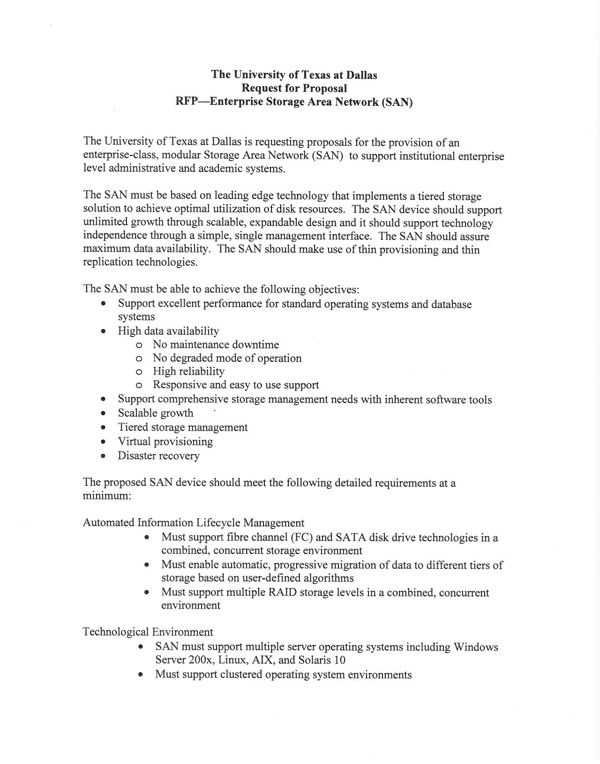
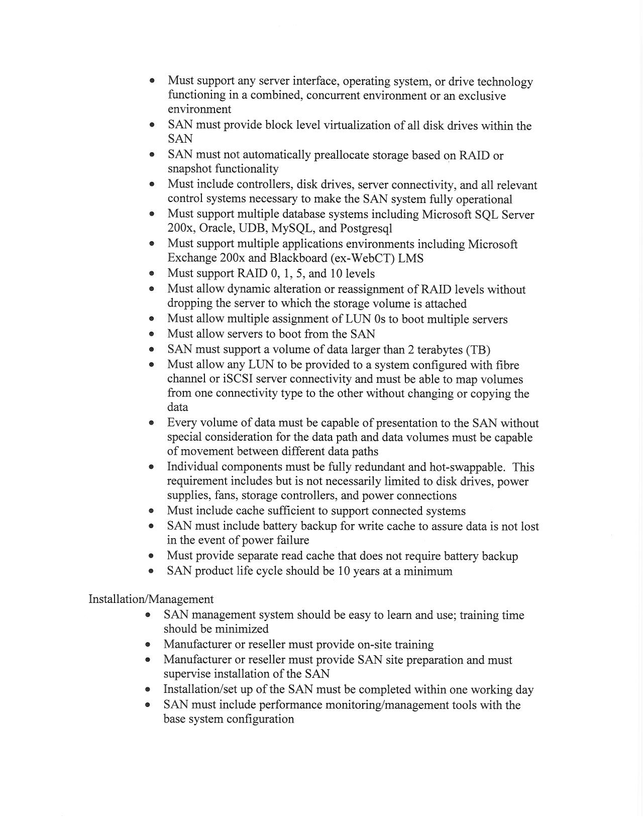
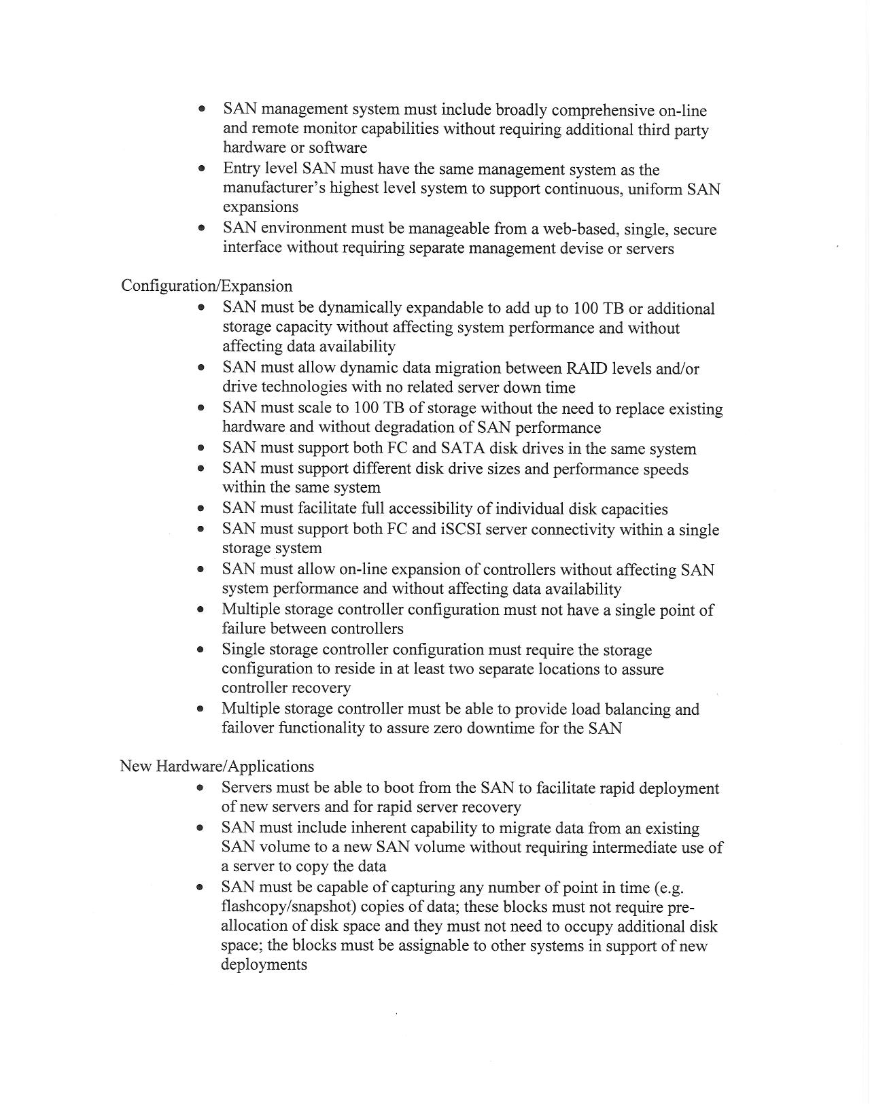
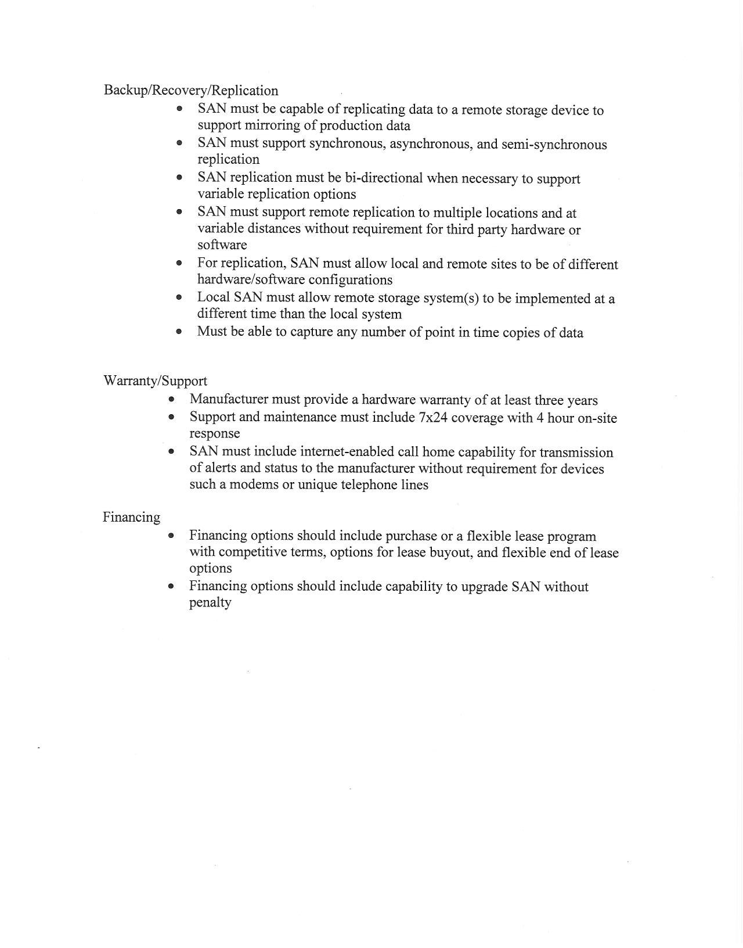

PRICING AND DELIVERY SCHEDULE

Proposal of: ___________________________________
(Proposer Company Name)

To: The University of Texas at Dallas UTD.

Ladies and Gentlemen:

Having carefully examined all the specifications and requirements of this RFP and any attachments thereto, the undersigned proposes to furnish the goods and services required pursuant to the above-referenced Request for Proposal upon the terms quoted below.
(Include as separate cost for the payment bond and for the performance bond.)

Pricing for Services Offered

________________________________________________________________

________________________________________________________________

________________________________________________________________

________________________________________________________________

________________________________________________________________

Delivery Schedule of Events and Time Periods

________________________________________________________________

________________________________________________________________

________________________________________________________________

________________________________________________________________

Include any detailed proposal here:

